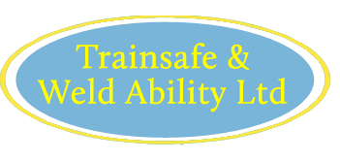 | 118 Straight Road Old Windsor Berks SL4 2SB  Phone/ Fax- 07768 361833  www.trainsafe.co.uk  michelle@trainsafe.co.uk

THE RIGHT WAY

A Guide to Fork Lift Truck Operations by David Harper

 | Price per book | No required | Total Price
1 – 49 | £4.00
50 – 149 | £3.10
Over 150 | £2.50

ADDITIONAL RULES

For use in conjunction with The Right Way Book (10 books per pack)

£10 per pack | No of packs | Total Price
Narrow Aisle truck
Pallet / Ride on Pedestrian stacker
Rough Terrain Telescopic Materials Handler
Side Loader truck
Bendi / Flexi truck (£13 per pack)

PRE SHIFT CHECK BOOK

For your use with your forklift fleet (12 books per pack) each book covers 1 month

 | Price | No of packs | Total Price
1 pack | £20.00

Please indicate above the type and quantities of books required and complete the details below and email to michelle@trainsafe.co.uk

On receipt of your order your invoice will be sent, books will be despatched on receipt of payment. Minimum orders of £40 please.

Company Name
Invoice Address | Delivery Address
For the attention of: | Purchase Order Number:
Telephone Number: | Fax Number:
Plus £10 per order post and packing | Order total £

